Intro to Java Week 2 Coding Assignment

**Points possible:** 70

|  |  |  |
| --- | --- | --- |
| Category | Criteria | % of Grade |
| Functionality | Does the code work? | 25 |
| Organization | Is the code clean and organized? Proper use of white space, syntax, and consistency are utilized. Names and comments are concise and clear. | 25 |
| Creativity | Student solved the problems presented in the assignment using creativity and out of the box thinking. | 25 |
| Completeness | All requirements of the assignment are complete. | 25 |

**Instructions:** In Eclipse, or an IDE of your choice, write the code that accomplishes the objectives listed below. Ensure that the code compiles and runs as directed. Take screenshots of the code and of the running program (make sure to get screenshots of all required functionality) and paste them in this document where instructed below. Create a new repository on GitHub for this week’s assignments and push this document, with your Java project code, to the repository. Add the URL for this week’s repository to this document where instructed and submit this document to your instructor when complete.

**Coding Steps:**

1. What do each of the following Boolean expressions evaluate to?

|  |  |
| --- | --- |
| **Boolean Expression** | **Answer** |
| true && false | false |
| true || false | true |
| false && false | false |
| true && (false || true) | true |
| false || (true && false) | false |
| false || 1 < 5 | true |
| 5 >= 4 && 1 > 3 | false |
| 10 < 4 || 1 > 4 | false |
| 12 >= 2 && 1 < 24 | true |
| “Hello”.charAt(0) == ‘h’ | false |

1. In Eclipse, create the following Boolean variables and choose what values they hold:
   1. isHotOutside
   2. isWeekday
   3. hasMoneyInPocket
2. Create the following variables (not boolean type, choose the best data type for the variable):
   1. costOfMilk
   2. moneyInWallet
   3. thirstLevel (how thirsty you are on a scale of 1-10)
3. Using the variables you created above and Boolean operators, create variables for the following scenarios:
   1. shouldByIcecream – this should be true if it is hot outside and there is money in your pocket
   2. willGoSwimming – this should be true if it is hot outside and it is not a weekday
   3. isAGoodDay – this should be true if it is hot outside, there is money in your pocket, and it is not a weekday
   4. willBuyMilk – this should be true if it is hot outside, and thirstLevel is greater than or equal to 3, and moneyInWallet is greater than or equal to 2 times the cost of milk.

Example: If I had the variables isWeekday and isSummer and I was going to create a variable isSchoolDay, I would do something like the following:

boolean isSchoolDay = isWeekday && !isSummer;

1. Create a new class called Loops. In the main method of this class, create the following loops with any variables you feel are needed:
   1. A while loop that prints all even numbers from 0 to 100
   2. A while loop that prints every 3rd number going backwards from 100 until we reach 0
   3. A for loop that prints every other number from 1 to 100
   4. A for loop that prints every number from 0 to 100, but if the number is divisible by 3, it prints “Hello” instead of the number, and if the number is divisible by 5, it prints “World” instead of the number, and if it is divisible by both 3 and 5, it prints “HelloWorld” instead of the number.

**Screenshots of Code:**

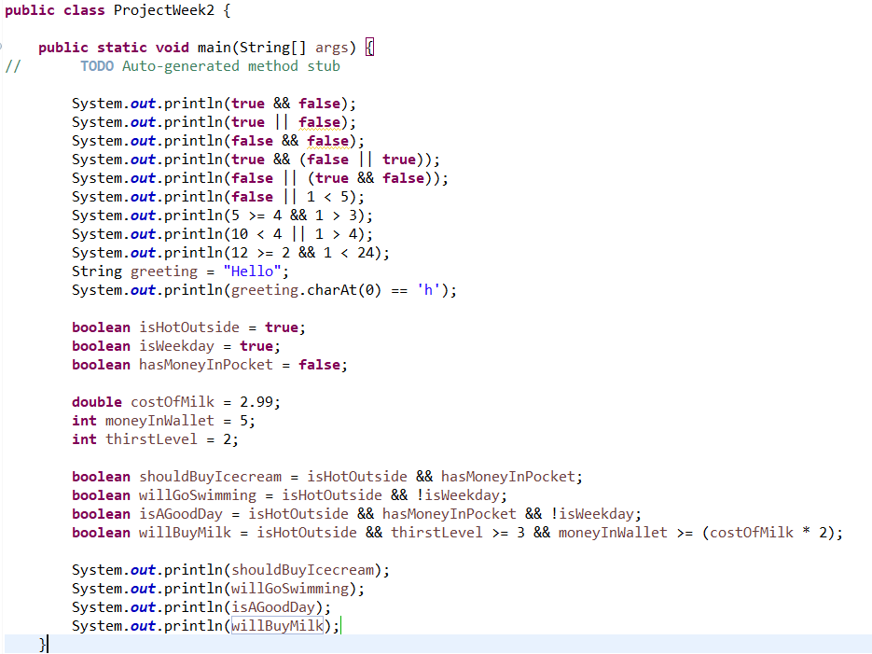

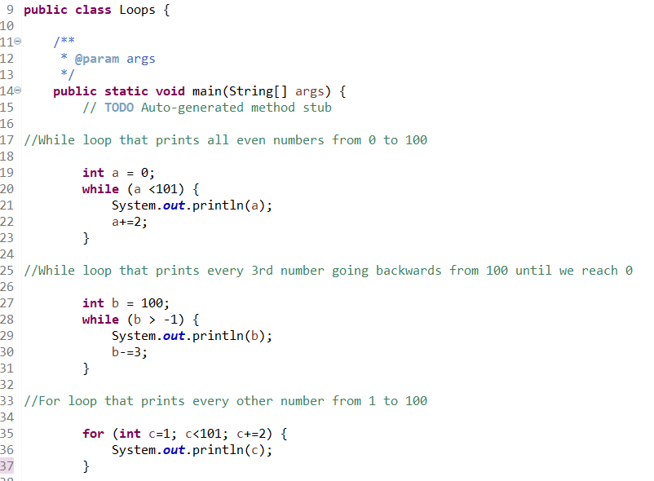

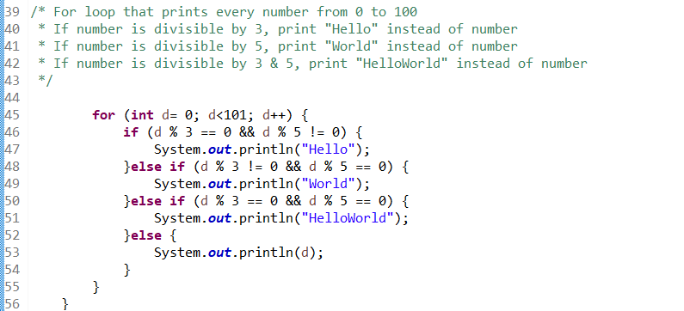

**Screenshots of Running Application:**

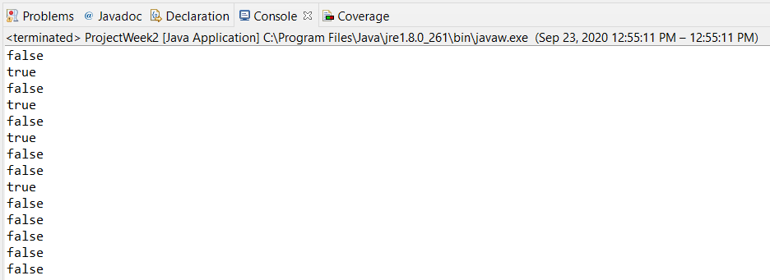

0

2

4

6

8

10

12

14

16

18

20

22

24

26

28

30

32

34

36

38

40

42

44

46

48

50

52

54

56

58

60

62

64

66

68

70

72

74

76

78

80

82

84

86

88

90

92

94

96

98

100

100

97

94

91

88

85

82

79

76

73

70

67

64

61

58

55

52

49

46

43

40

37

34

31

28

25

22

19

16

13

10

7

4

1

1

3

5

7

9

11

13

15

17

19

21

23

25

27

29

31

33

35

37

39

41

43

45

47

49

51

53

55

57

59

61

63

65

67

69

71

73

75

77

79

81

83

85

87

89

91

93

95

97

99

HelloWorld

1

2

Hello

4

World

Hello

7

8

Hello

World

11

Hello

13

14

HelloWorld

16

17

Hello

19

World

Hello

22

23

Hello

World

26

Hello

28

29

HelloWorld

31

32

Hello

34

World

Hello

37

38

Hello

World

41

Hello

43

44

HelloWorld

46

47

Hello

49

World

Hello

52

53

Hello

World

56

Hello

58

59

HelloWorld

61

62

Hello

64

World

Hello

67

68

Hello

World

71

Hello

73

74

HelloWorld

76

77

Hello

79

World

Hello

82

83

Hello

World

86

Hello

88

89

HelloWorld

91

92

Hello

94

World

Hello

97

98

Hello

World

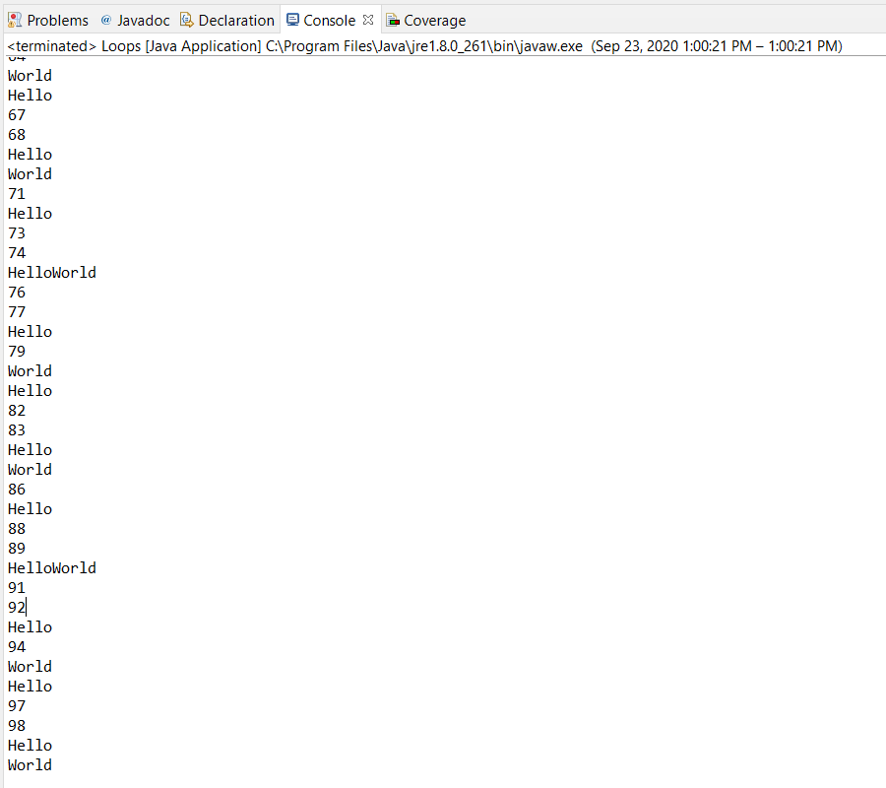

**URL to GitHub Repository:**

https://github.com/lrod8/ProjectWeek2